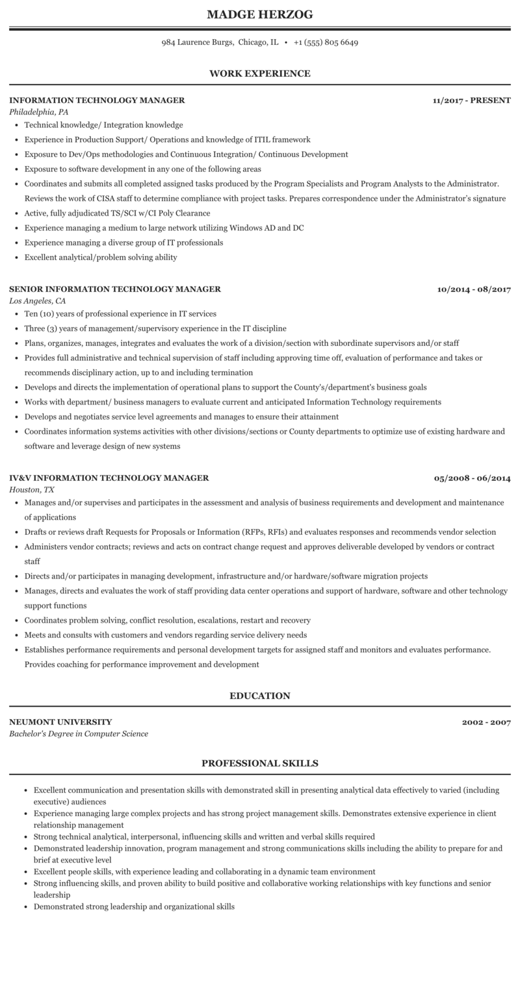
MADGE HERZOG
984 Laurence Burgs, Chicago, IL +1 (555) 805 6649
WORK EXPERIENCE
INFORMATION TECHNOLOGY MANAGER Philadelphia, PA
• Technical knowledge/Integration knowledge
• Experience in Production Support/ Operations and knowledge of ITIL framework
⚫ Exposure to Dev/Ops methodologies and Continuous Integration/ Continuous Development
• Exposure to software development in any one of the following areas
11/2017 - PRESENT
• Coordinates and submits all completed assigned tasks produced by the Program Specialists and Program Analysts to the Administrator. Reviews the work of CISA staff to determine compliance with project tasks. Prepares correspondence under the Administrator's signature • Active, fully adjudicated TS/SCI w/CI Poly Clearance
• Experience managing a medium to large network utilizing Windows AD and DC
• Experience managing a diverse group of IT professionals
• Excellent analytical/problem solving ability
SENIOR INFORMATION TECHNOLOGY MANAGER Los Angeles, CA
• Ten (10) years of professional experience in IT services
• Three (3) years of management/supervisory experience in the IT discipline
10/2014-08/2017
• Plans, organizes, manages, integrates and evaluates the work of a division/section with subordinate supervisors and/or staff
• Provides full administrative and technical supervision of staff including approving time off, evaluation of performance and takes or recommends disciplinary action, up to and including termination
• Develops and directs the implementation of operational plans to support the County's/department's business goals
• Works with department/ business managers to evaluate current and anticipated Information Technology requirements
• Develops and negotiates service level agreements and manages to ensure their attainment
• Coordinates information systems activities with other divisions/sections or County departments to optimize use of existing hardware and software and leverage design of new systems
IV&V INFORMATION TECHNOLOGY MANAGER Houston, TX
05/2008 06/2014
• Manages and/or supervises and participates in the assessment and analysis of business requirements and development and maintenance of applications
• Drafts or reviews draft Requests for Proposals or Information (RFPs, RFIs) and evaluates responses and recommends vendor selection ⚫ Administers vendor contracts; reviews and acts on contract change request and approves deliverable developed by vendors or contract staff
⚫ Directs and/or participates in managing development, infrastructure and/or hardware/software migration projects
• Manages, directs and evaluates the work of staff providing data center operations and support of hardware, software and other technology support functions
• Coordinates problem solving, conflict resolution, escalations, restart and recovery
• Meets and consults with customers and vendors regarding service delivery needs
• Establishes performance requirements and personal development targets for assigned staff and monitors and evaluates performance. Provides coaching for performance improvement and development
NEUMONT UNIVERSITY
Bachelor's Degree in Computer Science
EDUCATION
PROFESSIONAL SKILLS
2002-2007
• Excellent communication and presentation skills with demonstrated skill in presenting analytical data effectively to varied (including executive) audiences
• Experience managing large complex projects and has strong project management skills. Demonstrates extensive experience in client relationship management
• Strong technical analytical, interpersonal, influencing skills and written and verbal skills required
• Demonstrated leadership innovation, program management and strong communications skills including the ability to prepare for and brief at executive level
• Excellent people skills, with experience leading and collaborating in a dynamic team environment
• Strong influencing skills, and proven ability to build positive and collaborative working relationships with key functions and senior leadership
• Demonstrated strong leadership and organizational skills

